3.2-4) A *first order hold* (FOH) circuit can also be used to reconstruct a signal $x(t)$ from its samples. The impulse response of this circuit is:

$h\left(t\right)= Λ\left(\frac{t}{2T}\right)$, where T is the sampling interval

1. Let $x(t)=\sin\left(2πt\right) and T= 0.1s$

Then $x(t)$ will be sampled every 0.1s and $x_{\tilde{δ}}\left(t\right)=\sin\left(2πTn\right)=\sin\left(0.2πn\right)$ where n = … -2, -1, 0, 1, 2 …

In MATLAB,

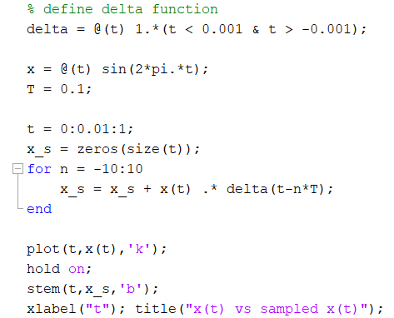

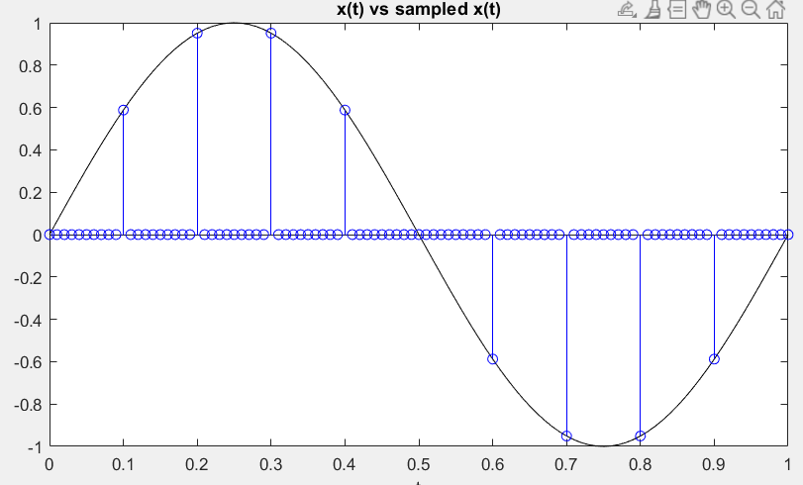

We know that $X_{\tilde{δ}}\left(ω\right)$ is a periodic replication of $X\left(ω\right)$ spaced by sampling frequency $f_{s}= T^{-1}=10Hz, ω_{s}=2πf_{s}$

So, $X\left(ω\right)$:

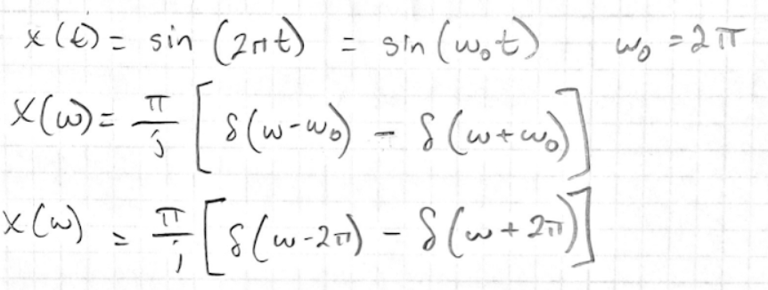

In MATLAB,

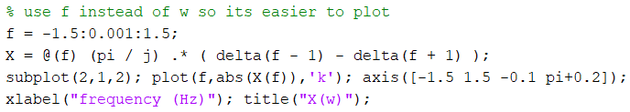

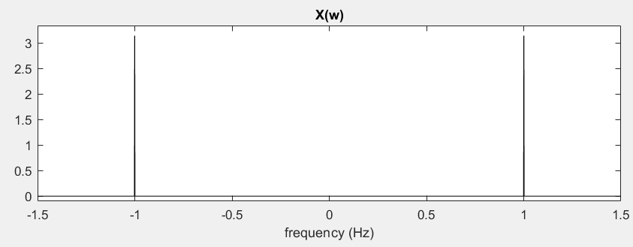

In MATLAB $h\left(t\right)=Λ\left(\frac{t}{2T}\right)$ looks like:

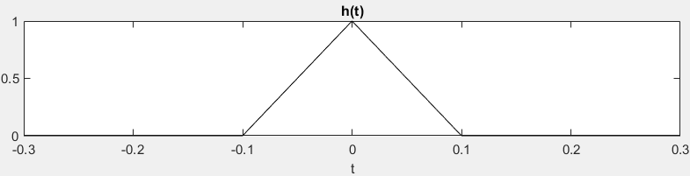

Then $H\left(ω\right)$ is: